1. **Write a simple program in HTML that displays the heading “I am happy to Learn Web Development” on the web browser.**

Ans.

<!DOCTYPE html>

<html lang="en">

<head>

    <title>1st HTML code in my Course</title>

</head>

<body>

    <!-- Write a simple program in HTML that displays the heading “I am happy to Learn Web Development” on

the web browser. -->

<h1>I am happy to Learn Web Development</h1>

</body>

</html>

1. **Write a simple program in HTML, the webpage must contain the heading “Comments” and below the heading add some information about comments. The webpage must be rendered on the web browser as below image.**

Ans.

<h1>Heading</h1>

p>lorem150

<hr/>

1. **Write a short note on tags, elements, and attributes along w­ith relevant examples.**

## Ans.

## Tags:

HTML tags are like keywords which defines that how web browser will format and display the content.

Example: <h1> ,< br/> ,< img>

1. **Elements**

An HTML element is defined by a start tag, some content, and an end tag. HTML Elements. The HTML element is everything from the start tag to the end tag.

Example: under the <p> to </p> tag everything is element

1. **Attributes:**

HTML attributes provide additional information about HTML elements. HTML Attributes. All HTML elements can have attributes

Example:  <img src=”” Alt=”” hight=”” , Width=”’ />

Where, Alt , hight, width all are the attribute.

1. **List out any 3 tags ­e learned in this module and give a brief explanation about the tags.**

Ans.

**HTML Paragraphs**

* The **<p>** tag in HTML defines a paragraph.
* There is a way to let the HTML know where the browser needs to change the lines by using the **<br/>** tag.
* **Align attribute:** The <p> tag specifically supports the alignment attribute and allows us to align our paragraphs in **left, right, or center** alignment.



**HTML Heading**

These 6 heading elements are h1, h2, h3, h4, h5, and h6; with h1 being the highest level and h6 being the least.

* **<h1>** is used for the main heading. (Biggest in size)
* **<h2>** is used for subheadings, if there are further sections under the subheadings then the
* **<h3>** elements are used.
* **<h6>** for the small heading (smallest one).

**HTML Tables:**

An HTML table is defined with the “table” tag. Each table row is defined with the “tr” tag. A table header is defined with the “th” tag. By default, table headings are bold and centered. A table data/cell is defined with the “td” tag.

<table>, <td> (Table Head), <tr> (table Row), <td> (Table Data)

1. **What is emmet? List some of the advantages emmet offers?**

Ans.

Emmet is a plugin for text editors that allows you to write CSS faster by using abbreviations that expand into full code.

It can save a lot of time when writing code because you can type a few characters and then expand them into a long block of code with a single keystroke. Emmet is a plugin for text editors that allows you to write CSS faster by using abbreviations that expand into full code.

**Advantages:**

Emmet is a free add-on for your text editor. It allows you to type shortcuts that are then expanded into full pieces of code. By using Emmet, developers type less, they save both on keystrokes and time. Also relying on Emmet's auto-completion means fewer typos and missing tags, leading to more robust and valid files.

It saves the time of programmer while writing the code.

1. **Using emmet create another w­ebpage similar to questions 1 and 2.**

Ans.

h1{I am happy to Learn Web Deve5opment}+h1{Heading}+p{lorem150}

1. **Explain in brief about the nesting operators in emmet.**

Ans.

Nesting operators are used to position abbreviation elements inside generated tree: whether it should be placed inside or near the context element.

**Child:**

You can use > operator to nest elements inside each other:

* div>ul>li

1. **Build a simple w­ebpage using any 2 emmet abbreviations and above the elements mention the emmet abbreviation using HTML comments. The below­ image is for reference..**

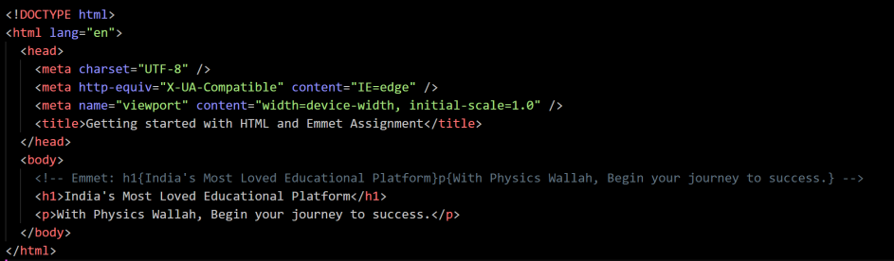

Ans.

1. ! then Enter.
2. H1{India’s Most Love Educational Plartfrom}+p{With Physics Wallah, Begin your journey to success} then Enter.
3. **What are self-closing tags? Write a brief note on meta tags>**

Ans.

**A self-closing tag** in HTML is a kind of HTML tag that does not need to be closed manually by its closing tag, which means it does not have a separate closing tag as </tag>. Some few self-closing tags are <input/>, <hr/>, <br/>, <img/>, etc.

1. **What are global attributes? List any 5 global attributes?**

Ans.

Global attributes are attributes common to all HTML elements; they can be used on all elements, though they may have no effect on some elements.

* **class**

A space-separated list of the classes of the element. Classes allow CSS and JavaScript to select and access specific elements via the class selectors or functions like the method Document.getElementsByClassName().

* **draggable**

An enumerated attribute indicating whether the element can be dragged, using the Drag and Drop API. It can have the following values:

true, which indicates that the element may be dragged

false, which indicates that the element may not be dragged.

* **lang**

Helps define the language of an element: the language that non-editable elements are in, or the language that editable elements should be written in by the user. The attribute contains one "language tag" (made of hyphen-separated "language subtags") in the format defined in RFC 5646: Tags for Identifying Languages (also known as BCP 47). xml:lang has priority over it.

* **style**

Contains CSS styling declarations to be applied to the element. Note that it is recommended for styles to be defined in a separate file or files. This attribute and the <style> element have mainly the purpose of allowing for quick styling, for example for testing purposes.

* **title**

Contains a text representing advisory information related to the element it belongs to. Such information can typically, but not necessarily, be presented to the user as a tooltip.